IBM ASSIGNMENT-I

(IOT based Safety Gadget for Child Safety

Monitoring And Notification )

Submitted by

RANJITH R

91761915028

CIRCUIT CONNECTION MADE

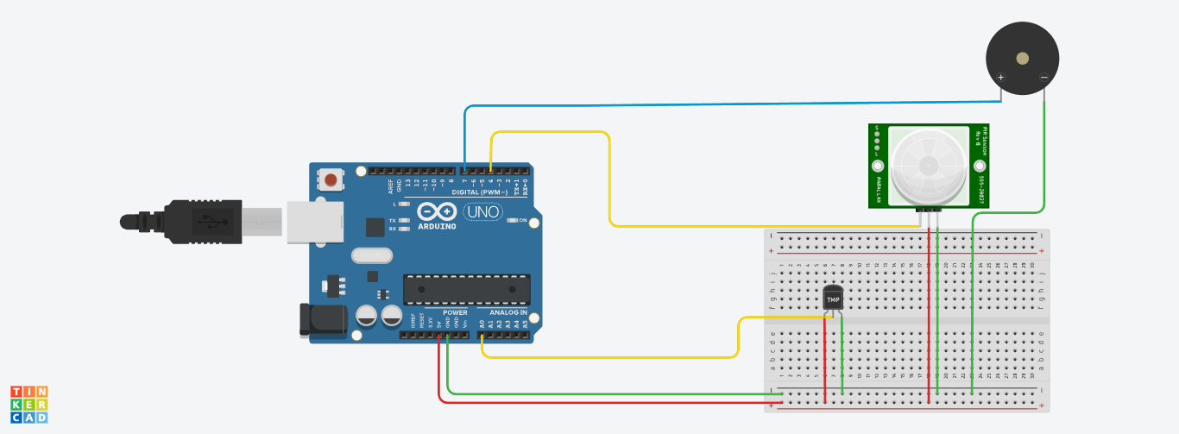

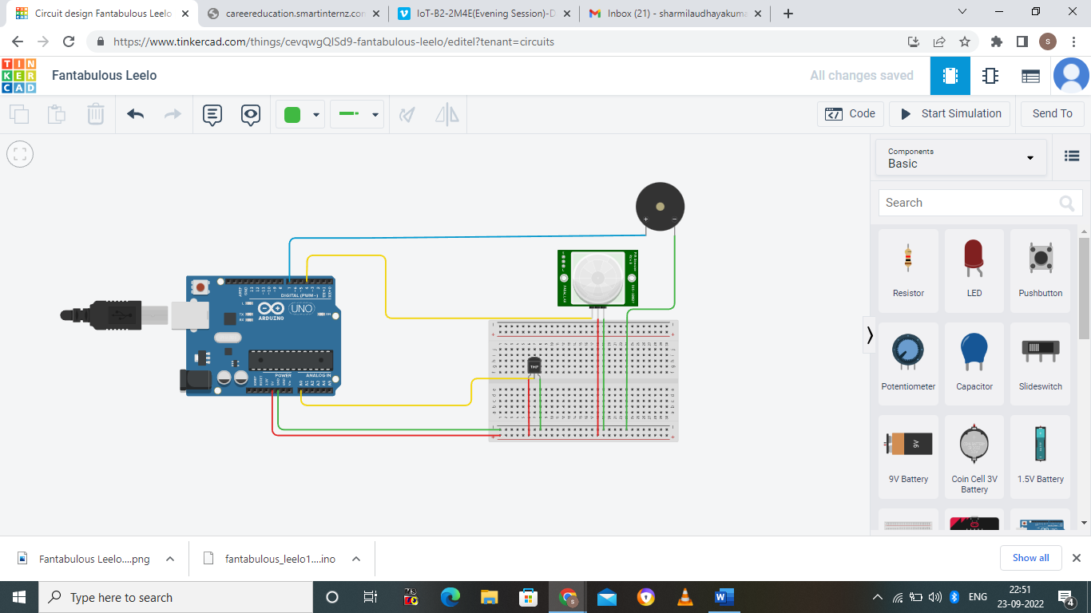

OUTPUT RECEIVED

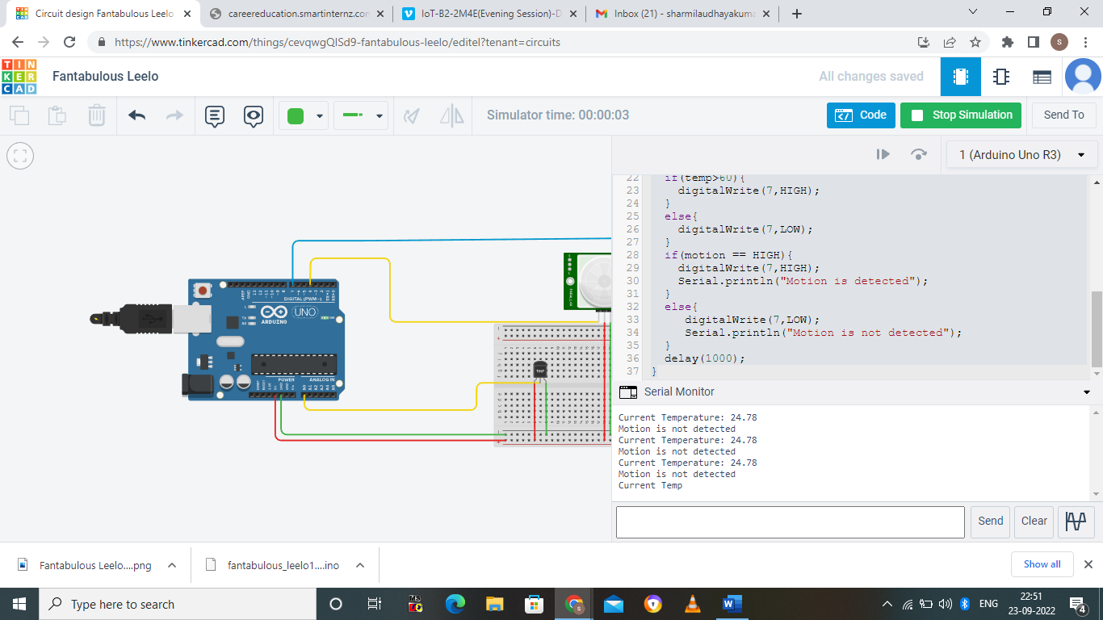

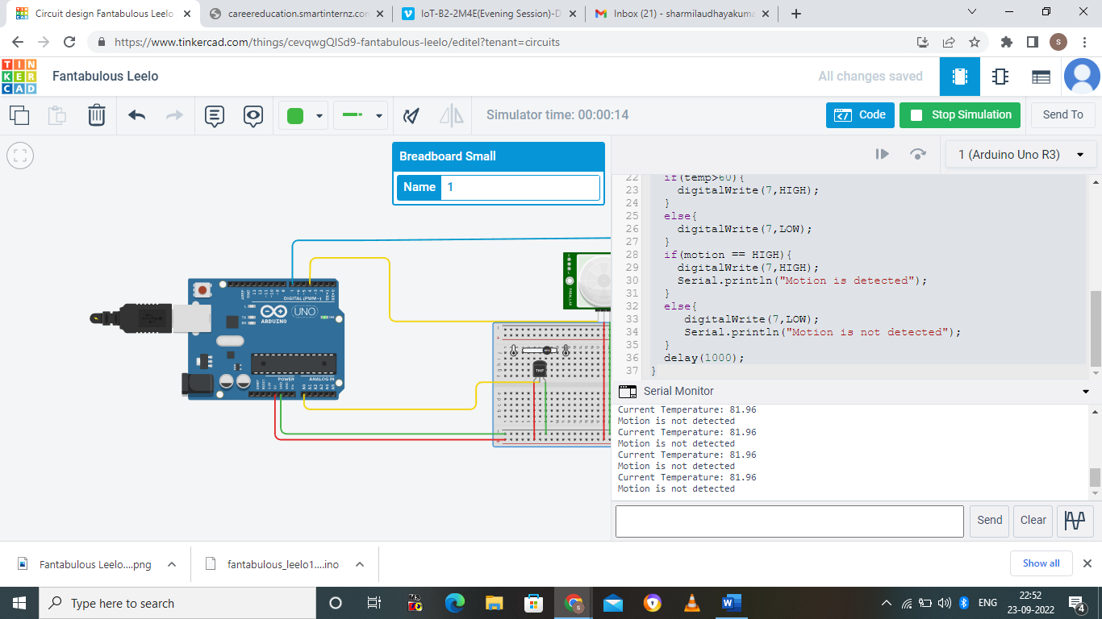



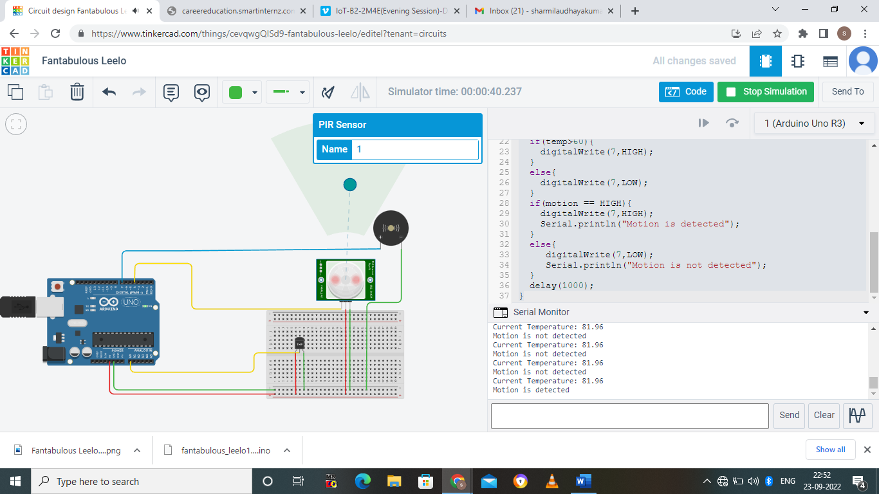

CODE

float vout,vout1,temp;

int motion=0;

void setup(){

pinMode(A0,INPUT);

pinMode(4,INPUT);

pinMode(7,OUTPUT);

Serial.begin(9600);

}

void loop(){

vout=analogRead(A0);

vout1=(vout/1023)\*5000;

temp=(vout1-500)/10;

motion=digitalRead(4);

Serial.print("Current Temperature: ");

Serial.print(temp);

Serial.println();

if(temp>60)

digitalWrite(7,HIGH);

else

digitalWrite(7,LOW);

if(motion == HIGH){

digitalWrite(7,HIGH);

Serial.println("Motion is detected");

}

else{

digitalWrite(7,LOW);

Serial.println("Motion is not detected");

}

delay(1000);

}